**Scotty Intondi**

**ENG 123**

**June.20.2021**

In history, women have always shown less interest in computer science than men. Although this is changing throughout the years, it will take decades and possibly generations for this gap to become equal from males to females. But why is this the case? Is it that women are not capable of doing the same task as men? I believe the reason for this is that women are just not into computer science because of stereotypes.

Women may be subjected to criticism in a workplace that tech is involved. However, this is in the workplace in which a person went to school and studied to get in the job. There is a gap by a long shot with gender when it comes to computer science. There is plenty of data that backs this up. However, this starts from a young age, what we observe and are involved in can influence our decisions for the future. Women even before attempting a job in tech must go to an university and from data we see the not many women enroll in computer science.

First, what we observe at a young age plays a big role in the choices we make in our future. Parents play a role in the kid's career choices as mothers are not usually involved with technology while the father is usually the one messing with the computer, playing with the home stereo system, and works in a job involved with tech. [**1**] Just from what is observed in our household can greatly impact our decision-making.

Next, how a computer science person is viewed or in other words stereotyped can influence one’s career choice. In the Science, Engineering, and Medicine (US); they concluded that assumptions and stereotypes about gender caused there to be fewer women pursuing degrees in these fields. [**2**] In a quote (“Starting in the 1980s,” Marie Desjardins says, “computers were marketed entirely to boys. Video games, same thing.” Men gravitated toward the industry, which came to be associated with “wild parties with striptease or nerdy guys in cubicles,” she adds.) [**3**] Assumptions and stereotypical insights greatly influenced women to less likely to get involved in computer science.

Finally, in the two charts below, we can see how over the years in the ’70s women had a higher interest in computer science and as the years gone by it has decreased. Whereas women got more interested in law, medical, or physical science throughout the years. Just recently in the past ten years have women started getting more interested in computer science. I believe this may be the case due to computer science being more generalized in college. And not because women have been growing interest in science all of the sudden. We can see that in the SWE chart below also. Where in the SWE chart we see that women enrolled in computer science only 3.7% of women intend to major in computer science in 2007 and 2017 it raised to 9.5%. 32% of women switch out of a stem program in college. Only 30% only women left a engineering position due to organizational climate. [**4**]

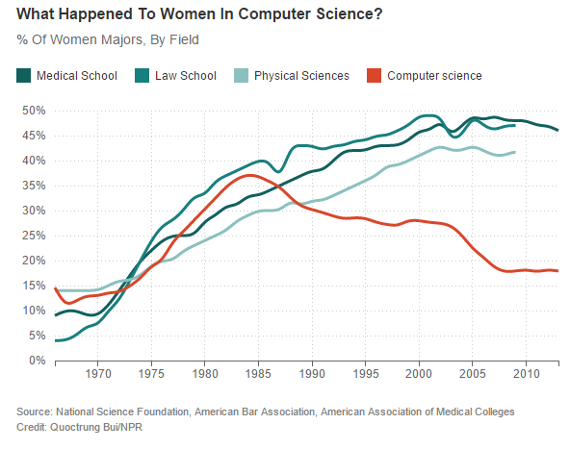

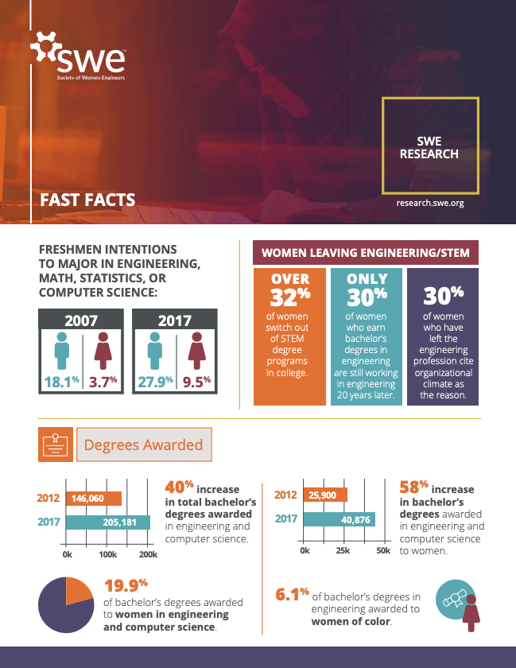

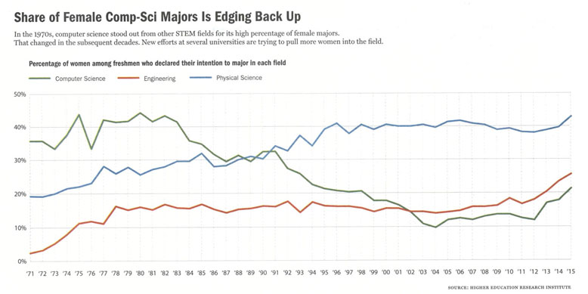

In conclusion, from stereotypes and observance, we are influenced by these very things when it comes to making career choices and other choices in that matter. We see how our parents can influence our decisions just by their everyday tasks and chores they do. We listen to our peers and parents and gather insight into what is acceptable and unacceptable in their eyes. This I believe is the reason why there is such a huge gap between women and men in computer science.

**References**

**[1] Holman, Luke, et al. "The gender gap in science: How long until women are equally represented?" *PLoS Biology*, vol. 16, no. 4, 2018, p. e2004956. *Gale In Context: Opposing Viewpoints*, gale.com/apps/doc/A536809473/OVIC?u=nhc_main&sid=OVIC&xid=8f3bebbe.**

**[2] Carlson, Scott. "Wanted: Female Computer-Science Students." *The Chronicle of Higher Education*, vol. 52, no. 19, 2006. *Gale In Context: Opposing Viewpoints*, gale.com/apps/doc/A147067497/OVIC?u=nhc_main&sid=OVIC&xid=496525d0.**

**[3] Gluckman, Nell. "Steering More Women to Silicon Valley." *The Chronicle of Higher Education*, vol. 64, no. 11, 2017, p. A8+. *Gale In Context: Opposing Viewpoints*, gale.com/apps/doc/A515974682/OVIC?u=nhc_main&sid=OVIC&xid=3b22c375.**

**[4] Rincon, Roberta. “SWE Research Update: Women in Engineering by the Numbers.” *All Together*, Research, 1 Nov. 2019, alltogether.swe.org/2019/11/swe-research-update-women-in-engineering-by-the-numbers-nov-2019.**